Top Schools Event Page Update:
Click Event:
Double click the event you want to add details to:
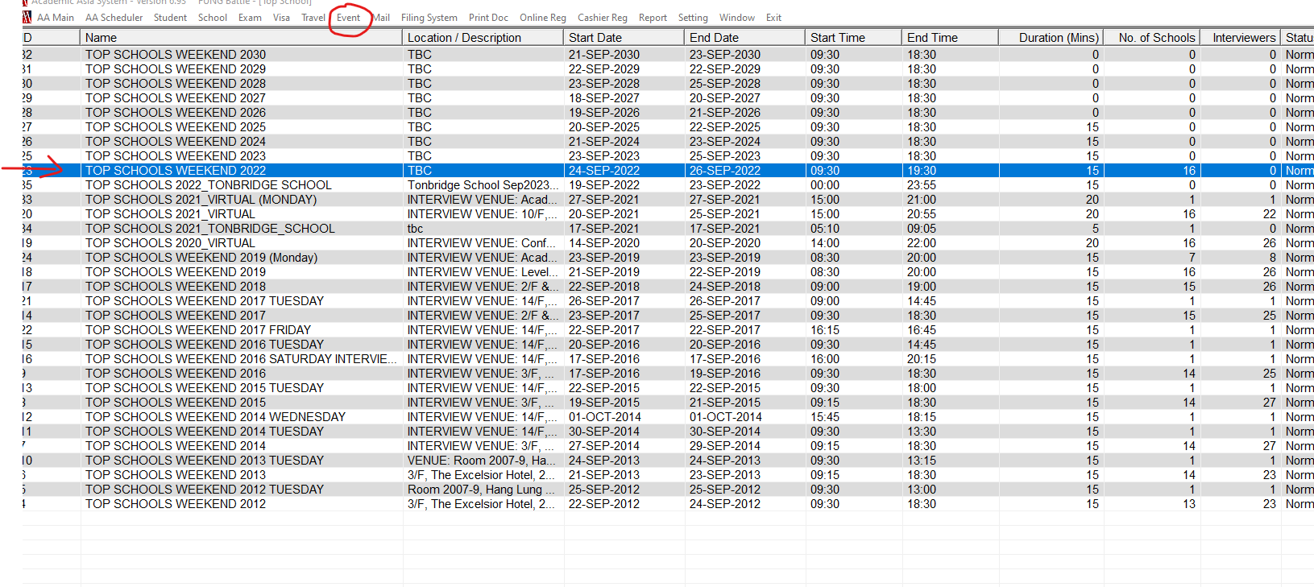
Click school:
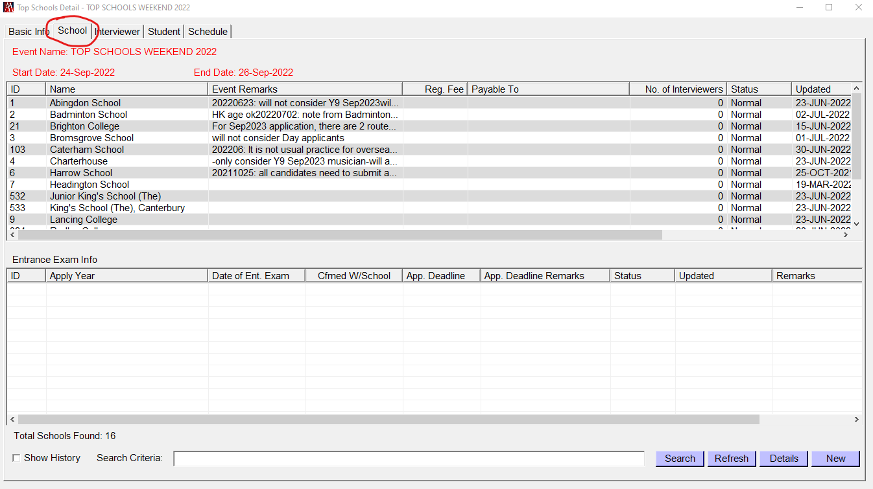

Double click school, then you can change the event details of that school:
At this part, you can add the details about event, Reg Fee and Payable to:
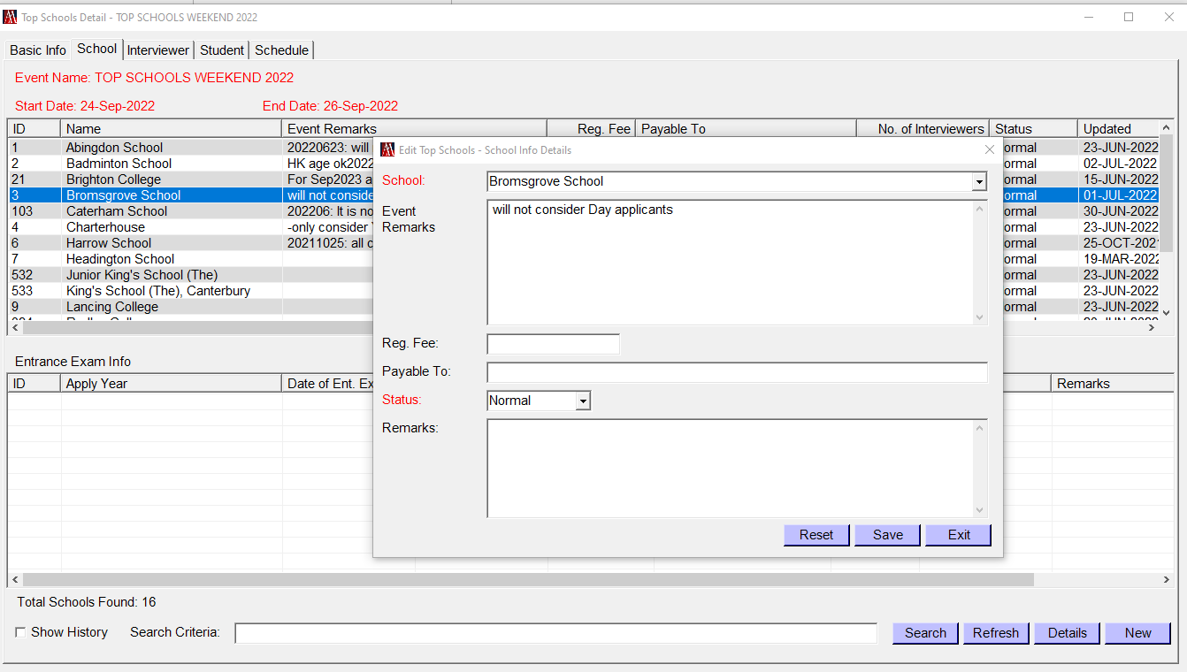
Move the cursor to the Entrance Exam Info lined area and right click or click New, then you can add the exam details of each year group
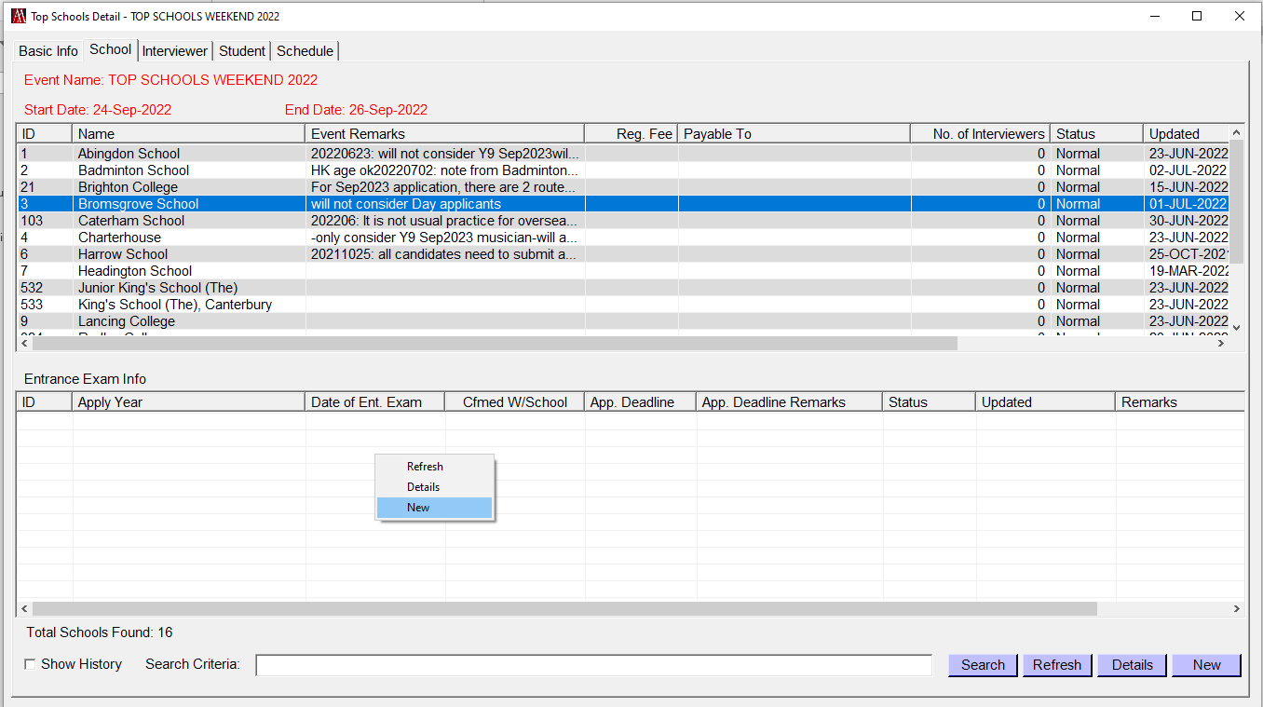

Add details as below then save:
